Report of Symposium
Dear all,
with your support we could organize our 13th International Symposium against Isolation in Paris this year, which gathered people from 20 countries.
It was important to continue this traditional and very important gathering, because we can also share the most recent topics we are busy with and create new relationship. At the same time, it is an announcement, that we don't end our efforts to strengthen our ties and carry on our common struggles.

We thank all delegates for being there and joining those days with us, even though not so easy sometimes. We look forward to a new meeting with you in a few months and will send some notes as proposal for a common declaration soon.

Following our news about the symposium. Sorry for the late distribution by E-Mail. It was only published at Facebook in the first days.
We would be also happy about your statements, news, photos, etc.
Many greeting to everybody..
IPAI

13th International Symposium Takes Place In Paris

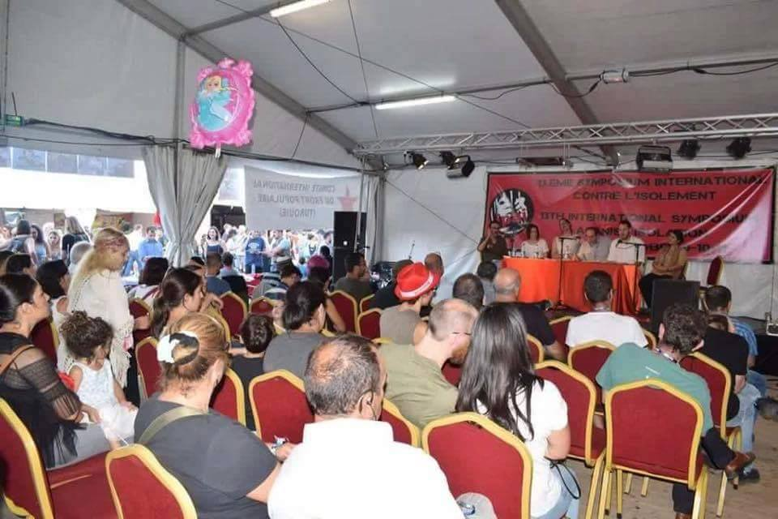
​
The 13th International Symposium took place on 9-11 September 2016 in Paris, dealing with and supporting the struggle against isolation in many countries of the world.
This year the symposium was held in a tent within the Fete de l'Humanite, and delegates from Ireland, Belgium, Palestine, Switzerland, the Netherlands, the Philippines, Colombia, Peru, Mexico, the USA, France, Germany, Austria, Argentina, Turkey, Morocco, Lebanon and Spain participated.

DAY 1 - September 9, 2016
On September 9, the delegates were greeted one by one and then there was a short speech of welcome. Then the first panel discussion took place, concerning the dimensions of racism in Europe and the United States.
The representative from the US Jericho Movement of former prisoners and the black liberation movement Masai Ehehoni, the African movement from France Brigade AntiNegrophobie and the Association of Political Refugees from Germany addressed the various dimensions of racism in their countries.
After dinner an international music programme was held.
The programme started with the hip hop artists from Germany Delirium Zyniker, there were Anatolian folk songs played by guitar and saz, and the latest African music group from France, Shaka Milo.
The well-attended programme lasted until midnight.

DAY 2 - September 10, 2016
The second day of the symposium began after breakfast was eaten by the participants in the tent, after which the session started. In the meeting the meaning of anti-imperialism and international solidarity and how to put them into effect were dealt with. Participants expressed their thoughts on the matter, one after the other.
The representative of the International Platform Against Isolation laid stress on failure to give an adequate response during years of imperialism's particular aggressiveness and massacres of the peoples. For this reason it was necessary to redefine the anti-imperialist struggle and to act, exhibiting clearer behaviour on this issue.
There was some discussion of holding a meeting in quieter settings than the Festival at a later date to discuss taking projects and action forward.
Another suggestion was to hold a people's festival opposing capitalist cultural degeneration, with participation of people from various countries.
In conclusion it was noted that in response to the huge refugee wave to Europe, anti-fascist and left forces had taken a civil society and humanist approach, but it was necessary for anti-imperialist and anti-fascist forces to expose the role of imperialism.
Later other participants recorded their thoughts one by one and decided that they would speedily take up work in this direction.
After lunch there was a session on the theme "socialism develops, capitalism corrupts".
Francisco Longa from Argentina's Dario Santillan People's Front referred to work in his country on people's schools and in shantytown neighbourhoods.
Barkin Timtik from the People's Law Bureau spoke in place of representatives from the Hasan Ferit Gedik anti-drugs centre in Istanbul and the Architects and Engineers of the People, who were not able to come to the Symposium because the French authorities had refused them visas. Timtik described repression of the Hasan Ferit Gedik centre, saying the police had occupied it and were trying to turn it into a police station. The panel set up a live link to a worker at the centre. The worker said every effort would be made to get the centre back, and called upon Symposium participants under every condition to aid this goal.
Pablo Hasel, who is under threat of a six-year jail sentence in the Spanish State, and exiled Grup Yorum member Ihsan Cibelik spoke.
In the final session of the second day, imperialist aggression from the Middle East to Eastern Europe and from Latin America to Asia was discussed.
In this session there were speakers from Switzerland's Network America Latina, the National Democratic Front of the Philippines, the lawyer from Lebanon Hassan Jouny, Driss Hani from Morocco, Hands Off Syria - No To War from Switzerland, and Bahar Kimyongur, a writer from Belgium.
In the session imperialist intervention in Brazil and Venezuela, the attacks of imperialism and Zionism in the Middle East and the role of European governments, especially the French state in these wars and resistance of the peoples to this were all recounted.
There was a five minute video message from Borotba in Ukraine, who spoke of the savage coup there years earlier to install a pro-American government which was now persecuting Communists and the left. About 850 people were missing in the past two and a half years after being arrested.
The evening music programme was this time by Grup Aksam Yorum. They danced the halay during a 1 and a half hour programme and this attracted attention from many people not part of the Symposium. This concert ended at about midnight.

DAY 3 – September 11, 2016
After breakfast on the third day, there was a seminar about political prisoners. The inner walls of the tent were decorated with pictures of revolutionary prisoners from the USA, Latin America and Europe, and there were also pictures created by Free Prisoners in Turkey.
The political prisoners' panel was joined by Republican Sinn Fein, the Irish Republican Prisoners' Support Group, June Kelly from Ireland,Paulette Dauteuil from the Jericho Movement from the USA, Barkin Timtik from the People's Law Bureau, Marco from the Prisoners' Union in Germany, and Suzanne from the solidarity committee for George Ibrahim Abdallah and the St Denis anti-imperialist solidarity committee, and Charlotte Kates from the Palestinian Samidoun prisoners' solidarity committee, took part. In this panel isolation and resistance and the common interests of the people were stressed. Prison resistance from Bobby Sands and those like him in Ireland to today and betrayal of this resistance, as well as imperialism's illegitimate courts at The Hague were described.
The September 9 prisoners' strikes in many US prisons and isolation practices were touched on. The F-Type prisons in Turkey were mentioned as being a US import and it was stressed that it would be very meaningful to enhance communication between prisoners from both countries.
The representative of the prisoners' union in Germany referred to the working conditions of prisoners in that country and its effects on the struggle. The resistance of the prisoners and people of Palestine and their honour were stressed, and greetings were sent from Ireland to the political prisoners of Turkey and the USA. It was also said that the 32 years of Georges Ibrahim Abdallah in French prisons could not be seen as separate from the Palestinian liberation struggle and both were greeted. The general resistance of revolutionary prisoners in Turkey was announced and it was stated that under no conditions would there be surrender to the enemy attacks and repression. It was reported that in a number of prisons actions and resistance by prisoners had forced the prison administration to take a step back.
After this panel the Symposium was officially ended and it was decided that a final declaration would be adopted on the three days of discussion and suggestions.

During the Symposium 15,000 pamphlets were distributed about the revolutionary democratic institutions of Turkey and stands collected signatures in seeking support and solidarity for the Hasan Ferit Gedik narcotics rehabilitation centre, which the police in Turkey have occupied.

23.09.2016 -Anadolu Newsblog

***

